**Program 2: Commission problem Sooraj M Singh**

**1CR18IS151**

**Program:**

#include<stdio.h>

int main()

{

    // Sooraj M Singh 1CR18IS151

    int locks, stocks, barrels, tlocks, tstocks, tbarrels;

    float lprice, sprice, bprice, sales, comm;

    int c1,c2,c3,temp;

    lprice=45.0;

    sprice=30.0;

    bprice=25.0;

    tlocks=0;

    tstocks=0;

    tbarrels=0;

    printf("\nEnter the number of locks and to exit the loop enter -1 for locks\n");

    scanf("%d",&locks);

    while(locks!=-1)

    {

        c1=(locks<=0||locks>70);

        printf("Enter the number of stocks and barrels\n");

        scanf("%d%d",&stocks,&barrels);

        c2=(stocks<=0||stocks>80);

        c3=(barrels<=0||barrels>90);

        if(c1)

            printf("Value of locks not in the range 1..70 ");

        else

        {

            temp=tlocks+locks;

            if(temp>70)

                printf("New total locks =%d not in the range 1..70 so old ",temp);

            else

                tlocks=temp;

        }

        printf("Total locks = %d\n",tlocks);

        if(c2)

            printf("Value of stocks not in the range 1..80 ");

        else

        {

            temp=tstocks+stocks;

            if(temp>80)

                printf("New total stocks =%d not in the range 1..80 so old ",temp);

            else

                tstocks=temp;

        }

        printf("Total stocks=%d\n",tstocks);

        if(c3)

            printf("Value of barrels not in the range 1..90 ");

        else

        {

            temp=tbarrels+barrels;

            if(temp>90)

                printf("new total barrels =%d not in the range 1..90 so old ",temp);

            else

                tbarrels=temp;

        }

        printf("Total barrel = %d",tbarrels);

        printf("\nEnter the number of locks and to exit the loop enter -1 for locks\n");

        scanf("%d",&locks);

    }

    printf("\nTotal locks = %d\nTotal stocks = %d\nTotal barrels = %d\n",tlocks,tstocks,tbarrels);

    sales = lprice*tlocks+sprice*tstocks+bprice*tbarrels;

    printf("\nThe total sales = %f\n",sales);

    if(sales > 0)

    {

        if(sales > 1800.0)

        {

            comm=0.10*1000.0;

            comm=comm+0.15*800;

            comm=comm+0.20*(sales-1800.0);

        }

        else if(sales > 1000)

        {

            comm =0.10*1000;

            comm=comm+0.15*(sales-1000);

        }

        else

            comm=0.10*sales;

        printf("The commission is = %f\n",comm);

    }

    else

        printf("There is no sales\n");

    return 0;

}

**Program Screenshots:**

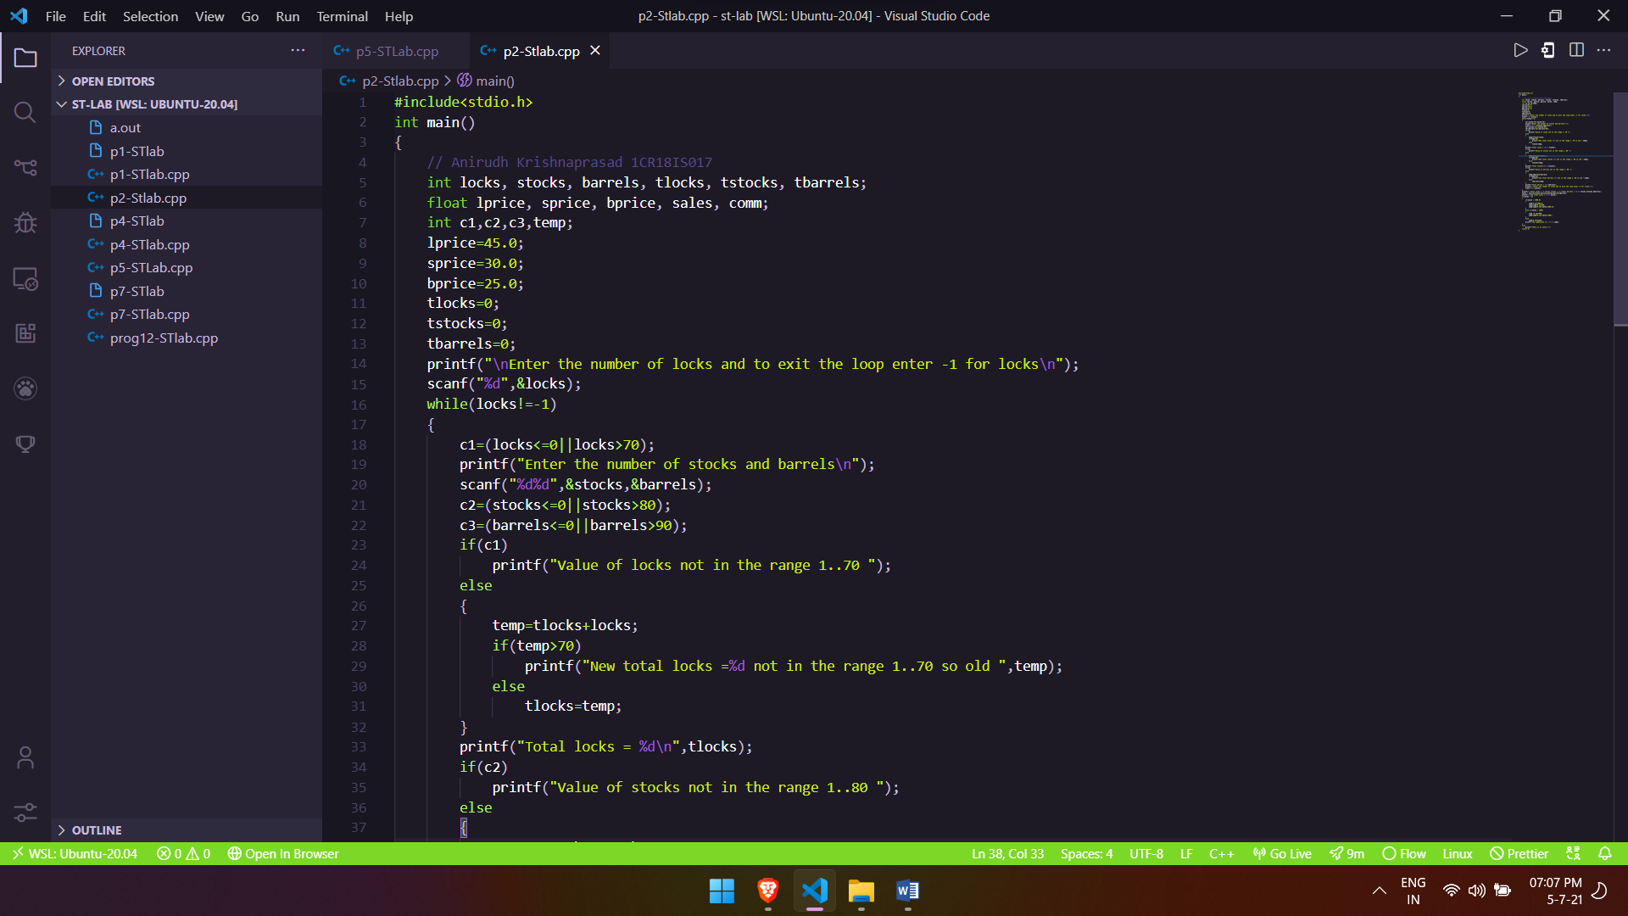

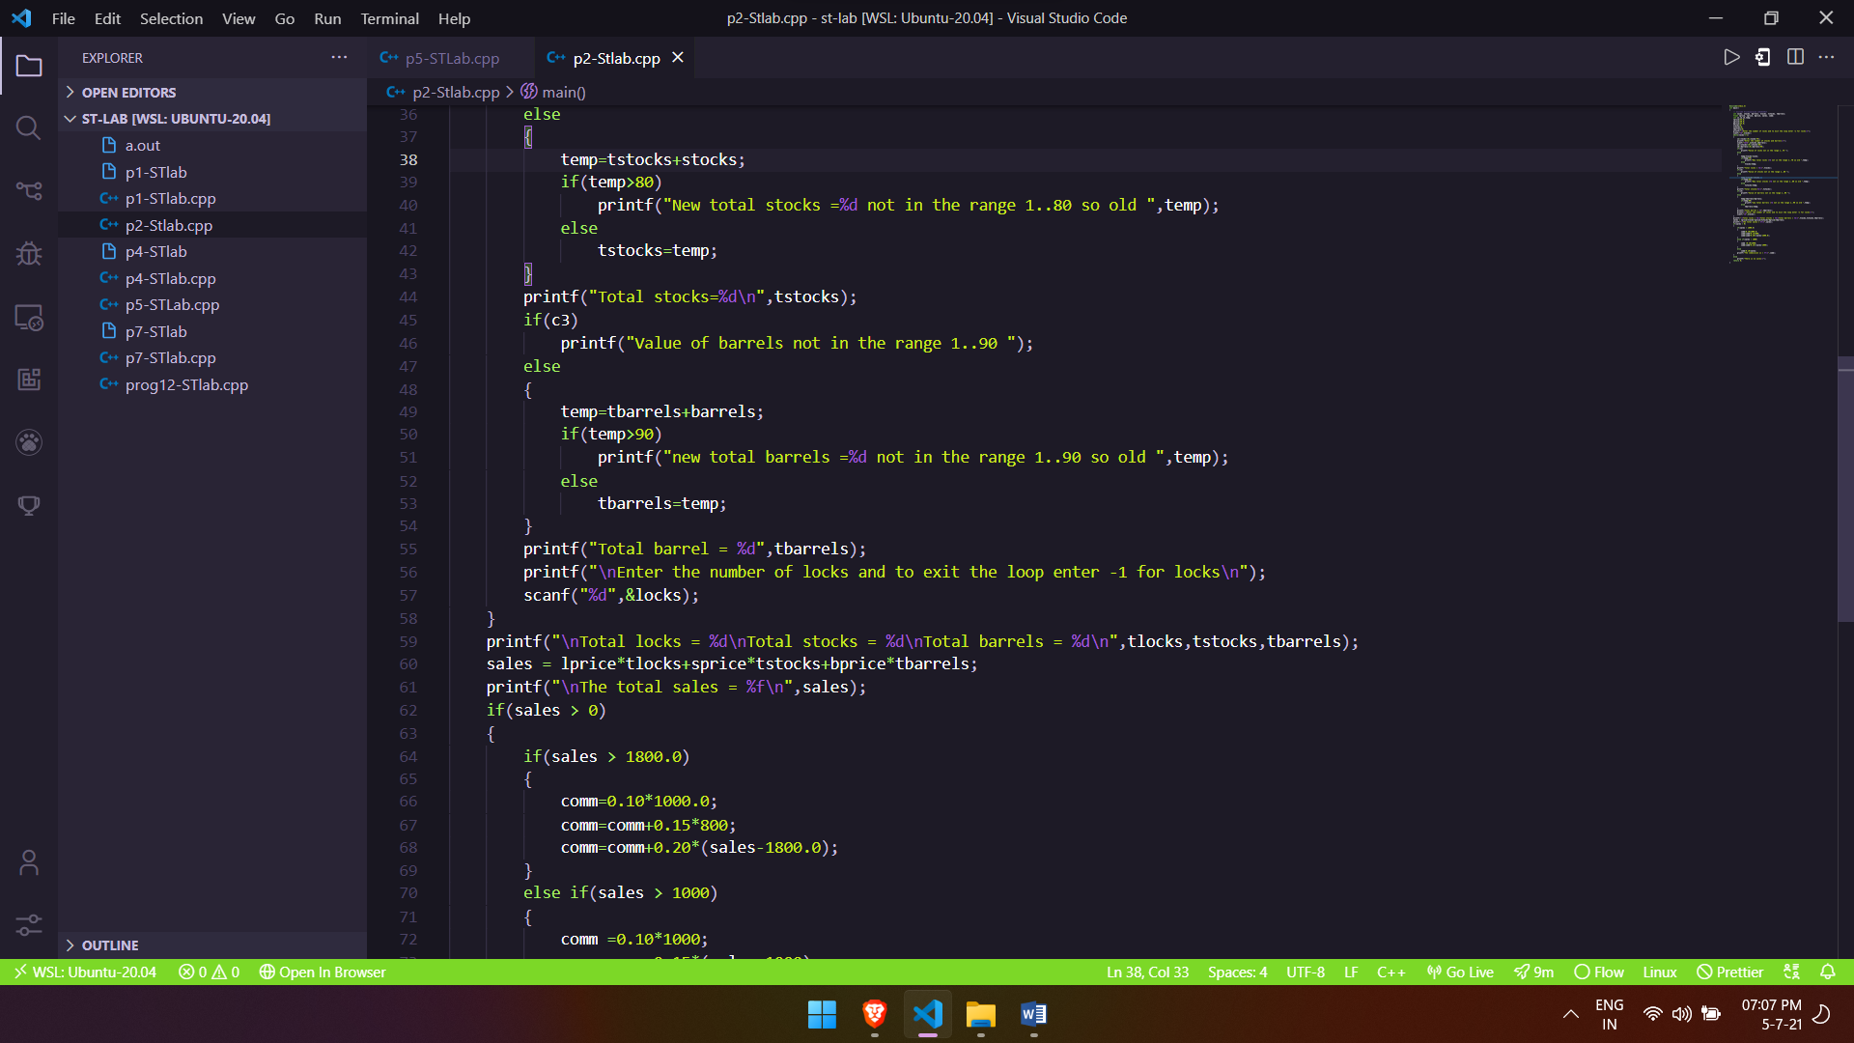

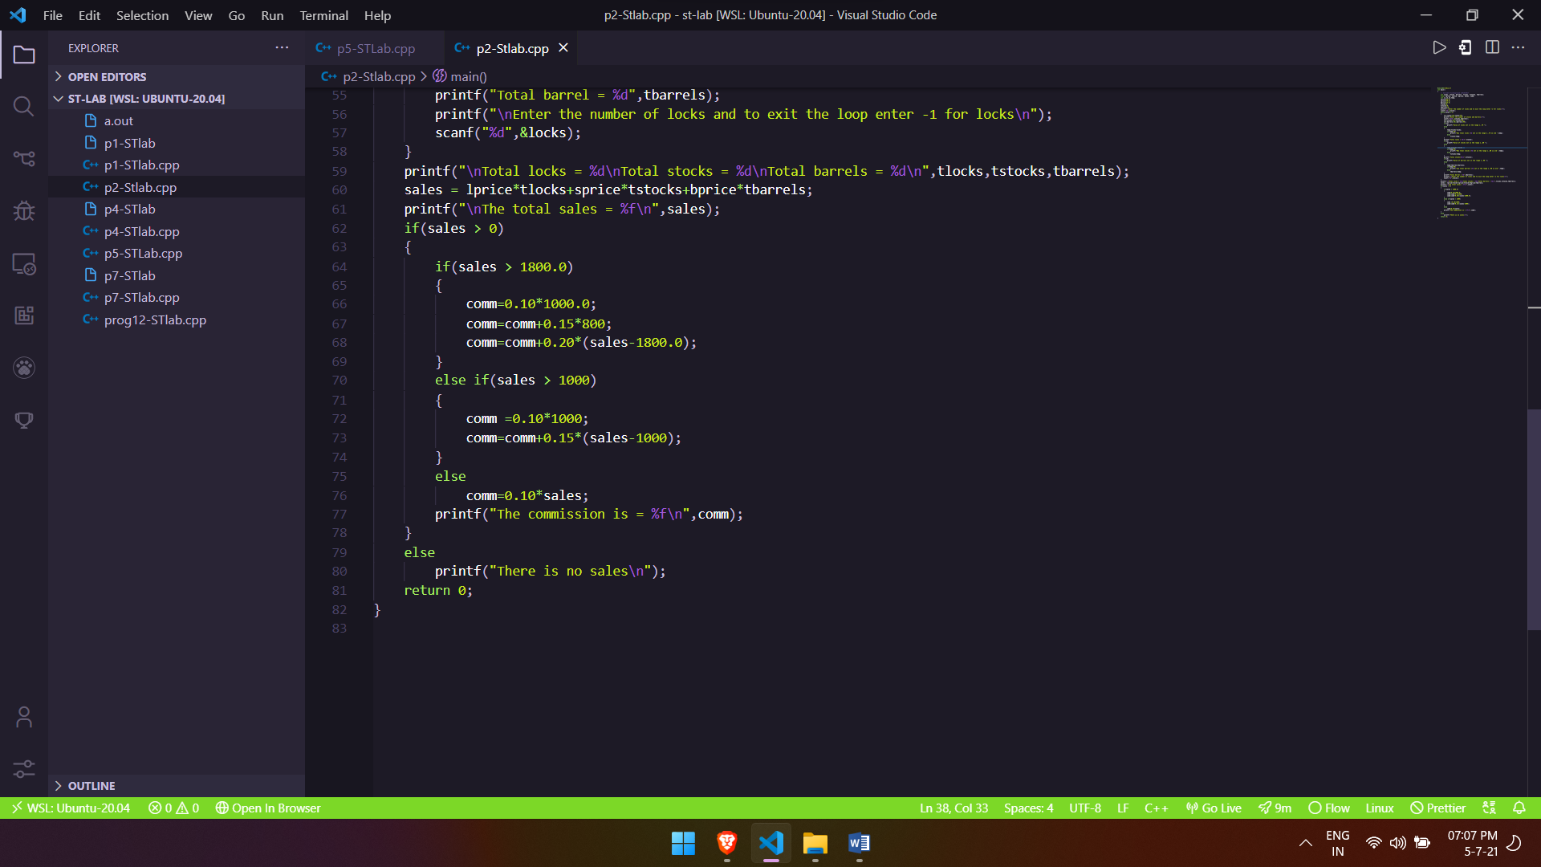

**Output screenshots:**